ELEC 152 - CIRCUIT THEORY I

PROBLEMS. When solving the problems of this exam, you must show all your work in order to receive any credit. Write your answers in the boxes when provided. Writing only the answers will result in no credit being given. Each problem is worth 15 points.

Problem 1: Determine the Thevenin Equivalent circuit as seen from terminals A and B in the sketch:
R_{th}

V_{th}

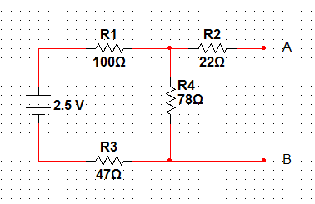

Problem 2: Using the Superposition theorem, determine the current through the resistance R2 and the voltage across the resistor R1 in the sketch below:
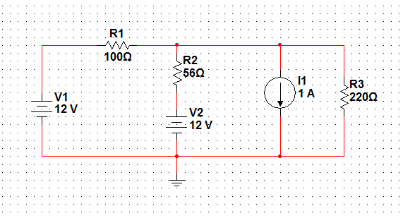
I_{R2}

V_{R1}

Problem 3: Apply Mesh Analysis to calculate the voltage V_{AB} (Voltage across R9) in the below sketch:
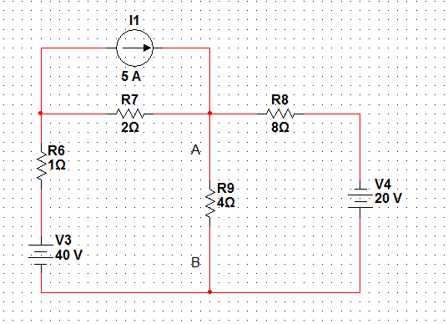

V_{ab} =

Problem 4: Use nodal analysis to calculate the current through Resistor R3 in the below sketch:
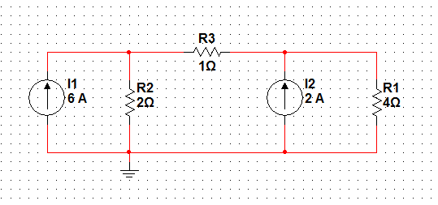
I_{R3} =

Problem 5: Find the equivalent capacitance as seen from Terminals A-B in the sketch below:
C_{eq} =

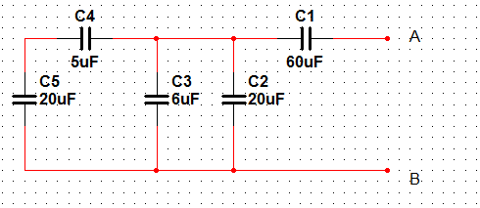

Problem 6: Assuming steady-state conditions, find the current through inductor L1 and the voltage across Resistor R2 in the circuit shown below.
I_{L1}

V_{R2}

